**Hosting a WordPress Website on Amazon EC2**

This document explains how to use Amazon EC2 to host a WordPress and connect it to a custom domain using Apache webserver and MySQL database.

**Following are the Steps to host a wordpress website on Amazon EC2 with custom domain:**

Step 1: Setup Amazon EC2 instance

Step 2: Install apache webserver

Step 3: Install MySQL database

Step 4: Download and install wordpress

Step 5: Link a custom domain to a website

**Step1: Setup Amazon EC2 instance**

Open Amazon EC2 console

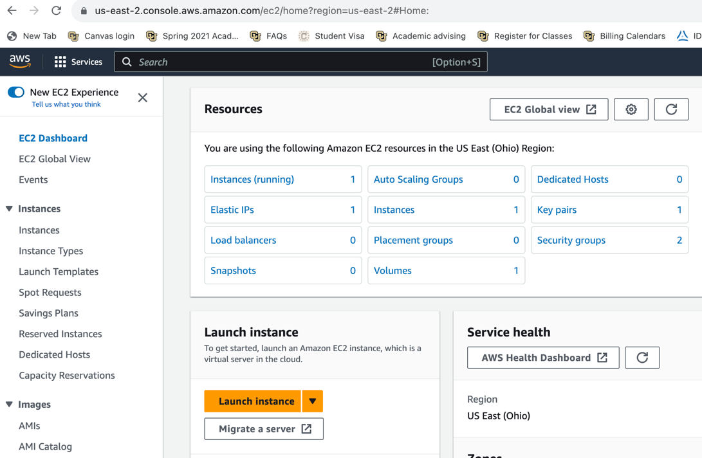

Click on “Launch instance” and enter an instance name

Name : My wordpress server

Application and OS Images (Amazon Machine Image) : Ubuntu

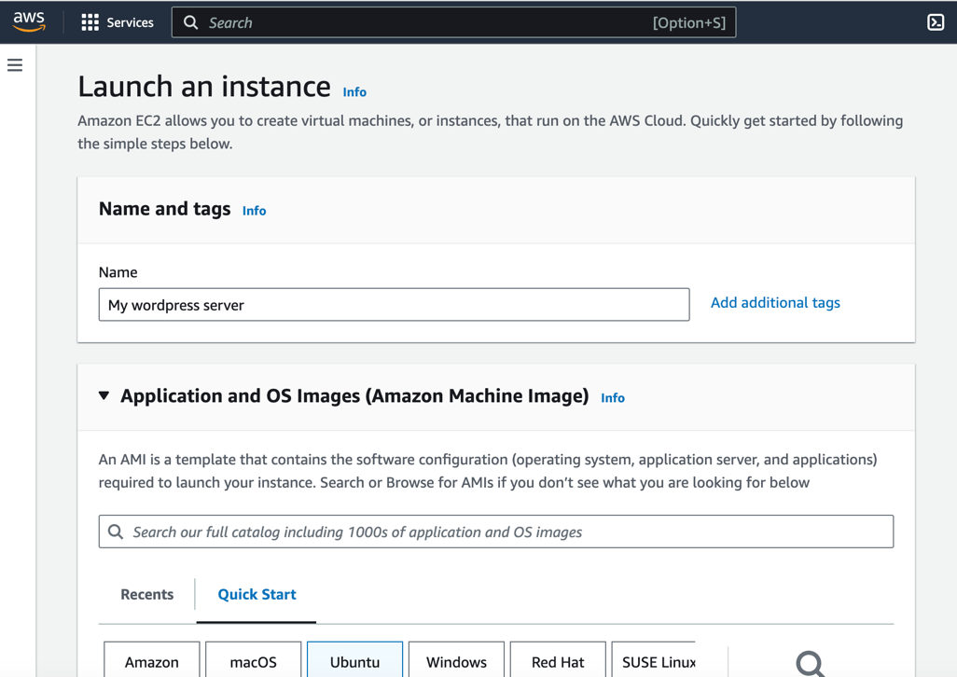

Instance type : t2.micro

Key pair: wordpress_server , others as default click on “create key pair”

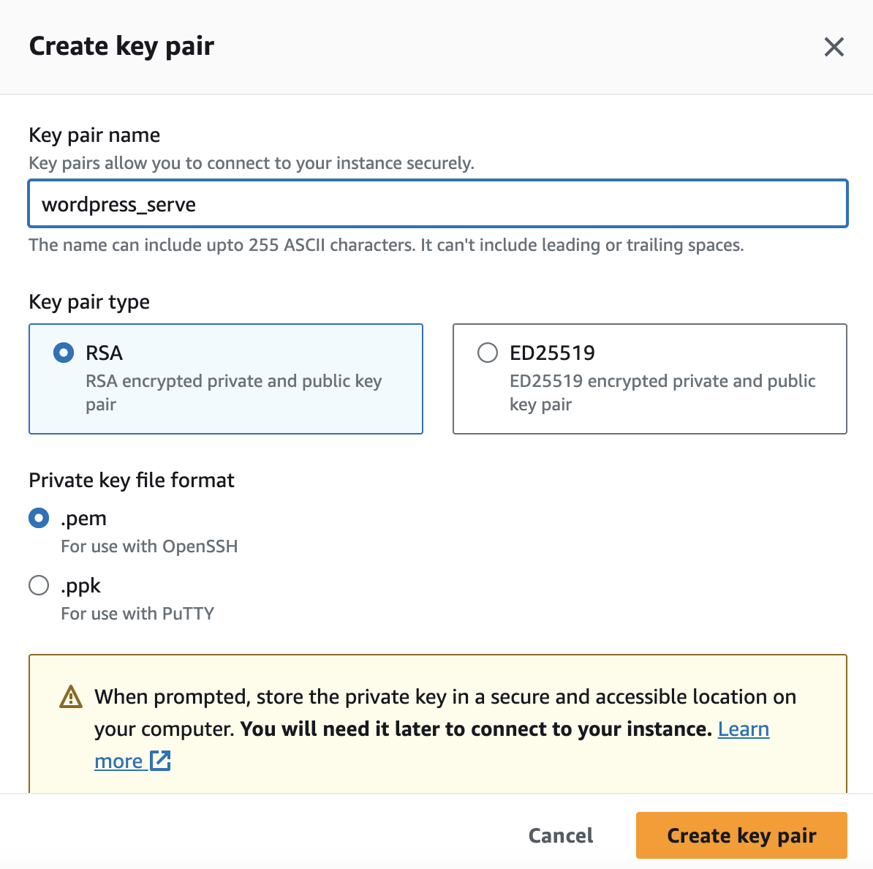

This downloads the wordpress_server.pem file (Secure file)

Under network settings, enable all the three traffic

Allow SSh traffic from

Allow HTTPs traffic from the internet

Allow HTTP traffic from the internet

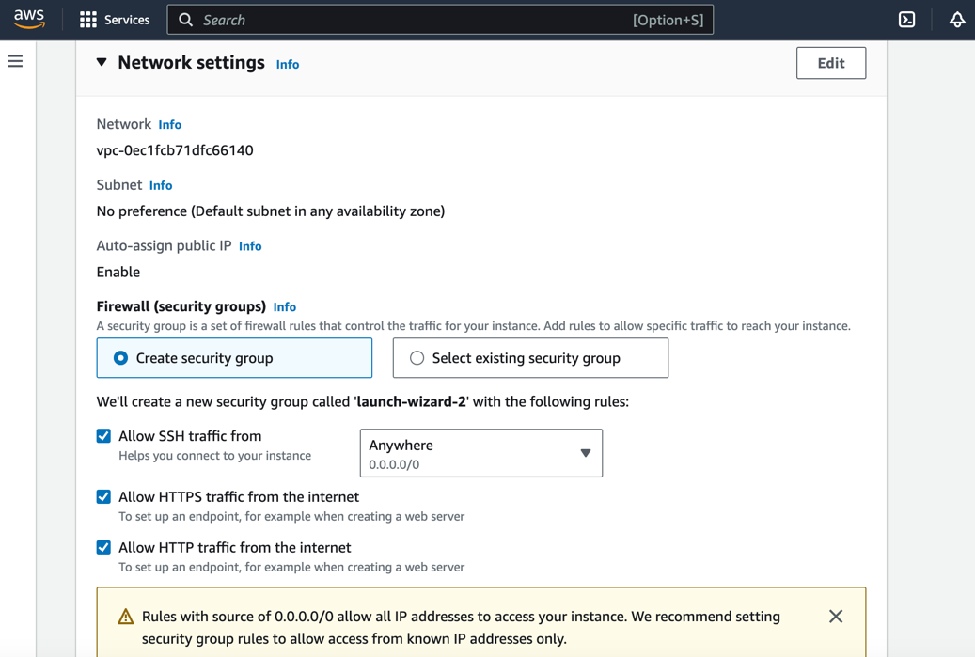

Others as default and finally click on “Launch instance”

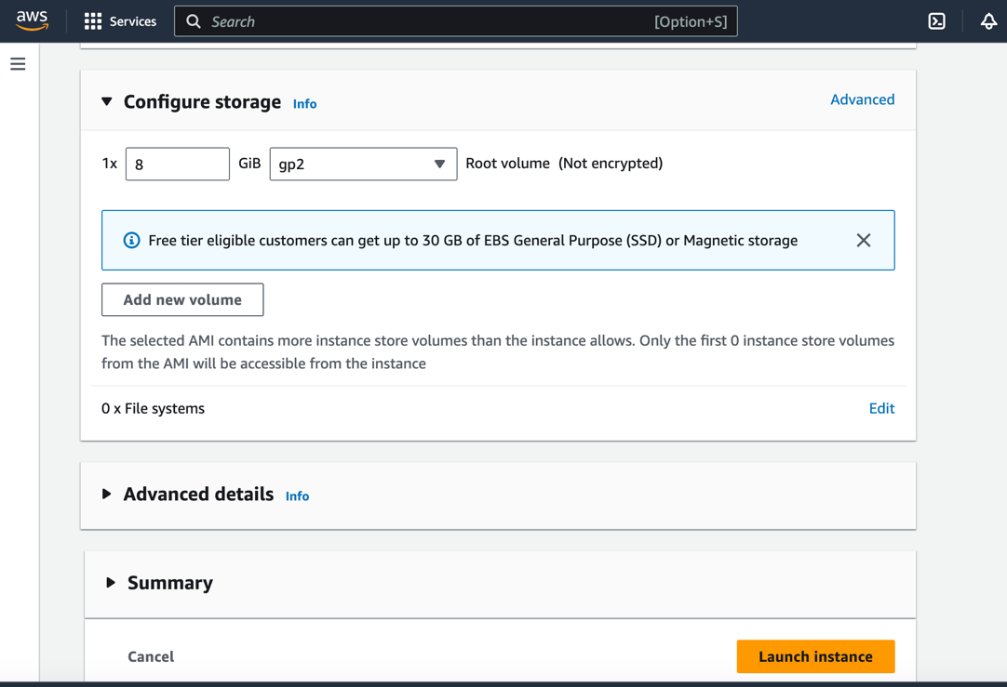

Once the instance is created, now assign the Elastic Ip address in order to have constant public IPV4 address.

Goto EC2 dashboard, click on “Elastic IPs”, click on “Allocate Elastic IP address”, and click on “Allocate”. Now created Elastic IP address.

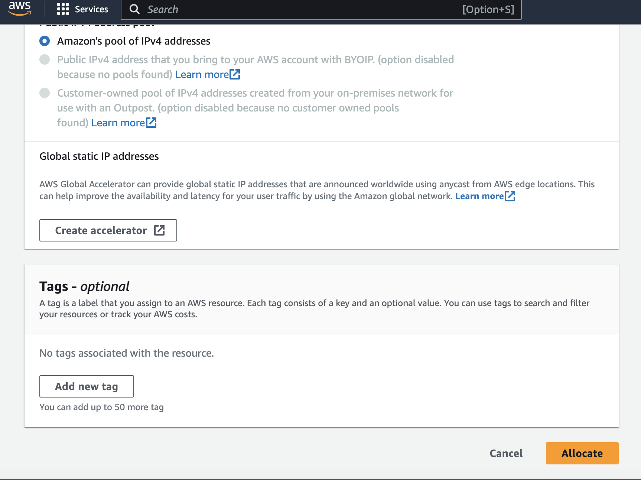

Select the Elastic IP address created and Goto Actions and select the Associate Elastic IP address. Here choose an EC2 instance and click on “Associate”.

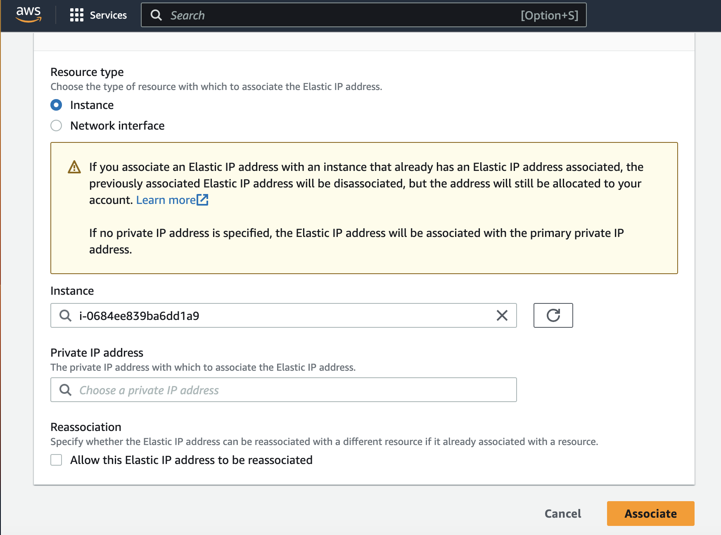

Now you can see public IPV4 address is changed and is same as Elastic IP.

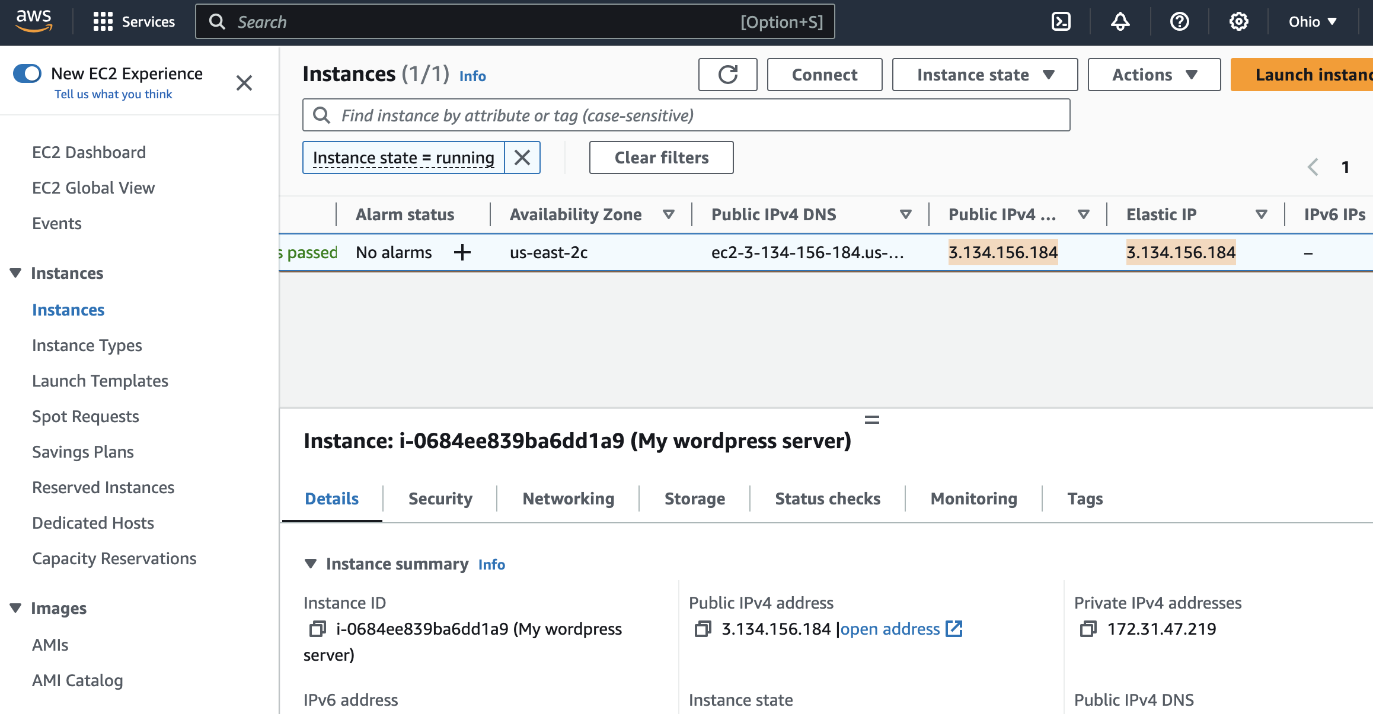

Open the SSH client (terminal)

Locate your private key file. The key used to launch this instance is wordpress_server.pem

Run this command, if necessary, to ensure your key is not publicly viewable.

chmod 400 wordpress_server.pem

Right click on the instance created, click on “connect”.

Under SSH client section, there is command to connect through SSH.

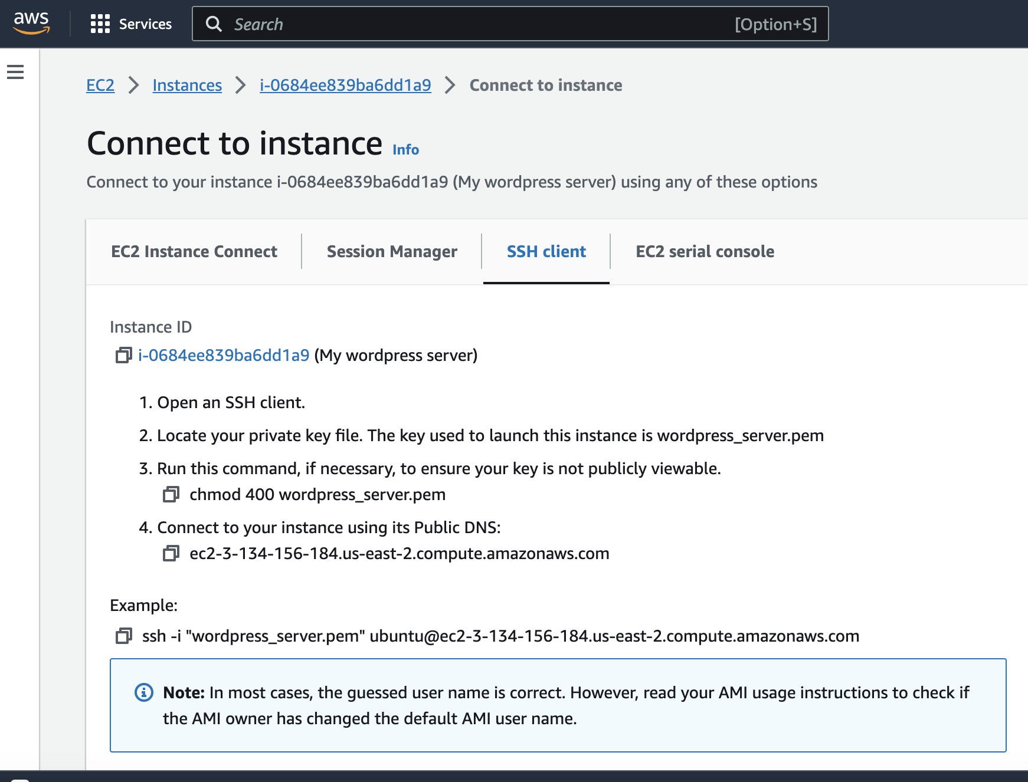

Connect to your instance in SSH client

ssh -i "wordpress_server.pem" [ubuntu@ec2-3-134-156-184.us-east-2.compute.amazonaws.com](mailto:ubuntu@ec2-3-134-156-184.us-east-2.compute.amazonaws.com)

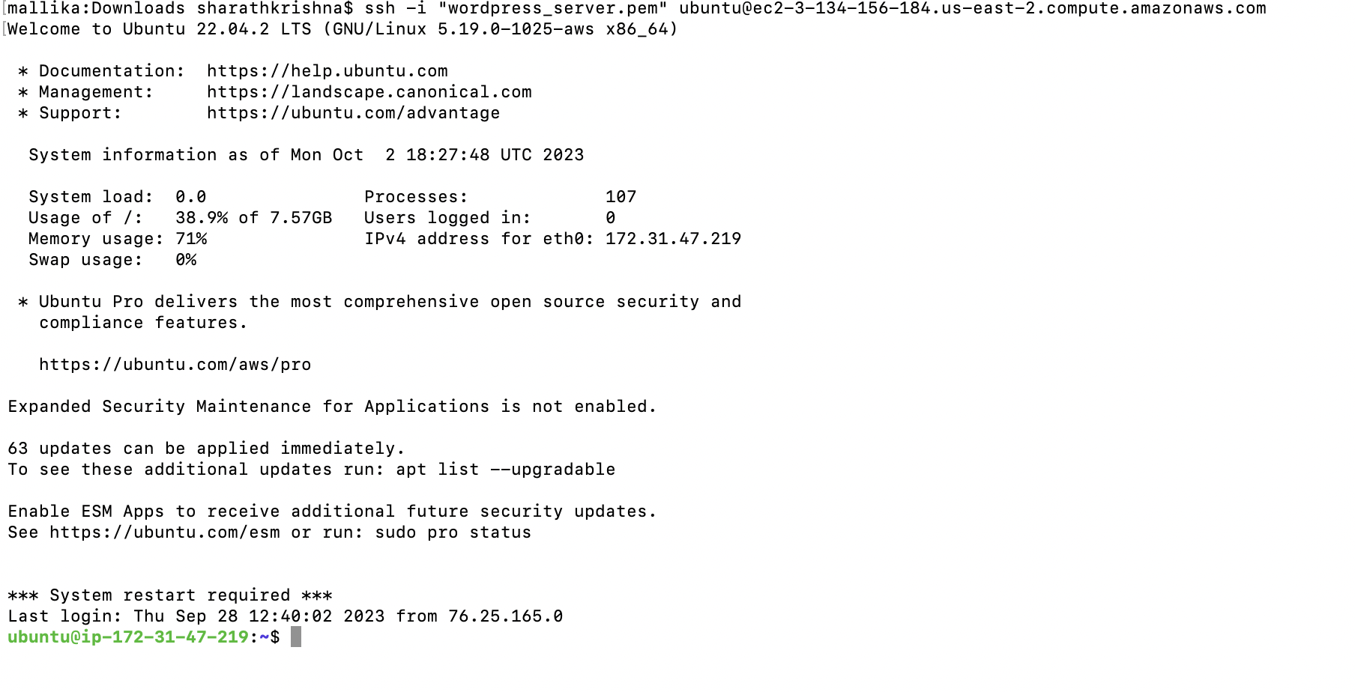

Now you are connected to your instance.

**Step2: Install Apache Webserver**

sudo apt install apache2

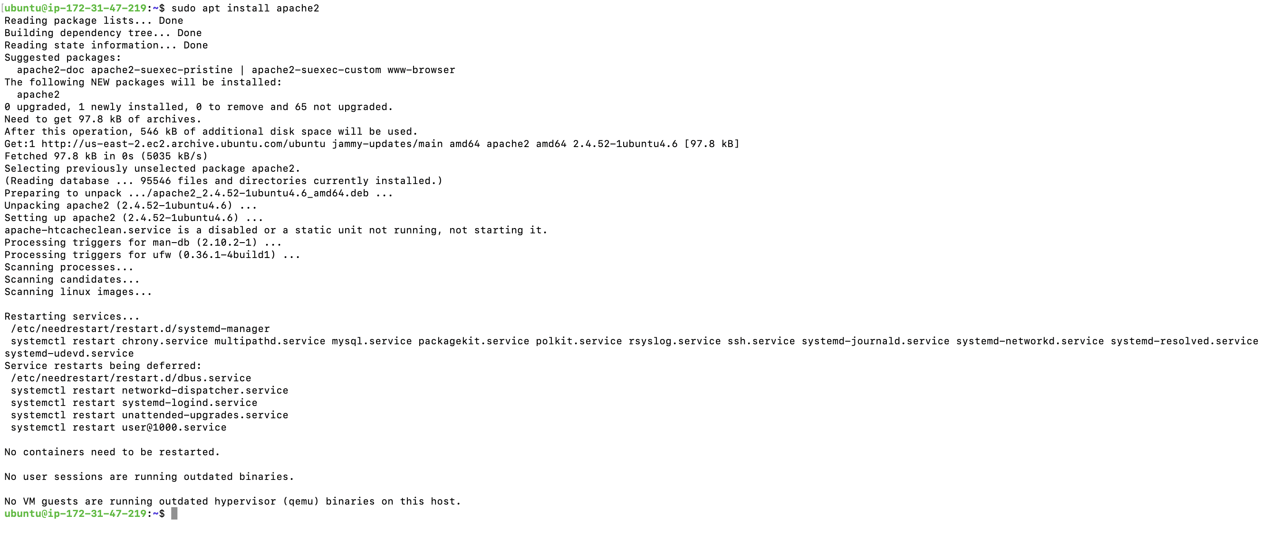

Cross Verify if the webserver is working, In the browser open the public IPV4 address and check the apache2 default page.

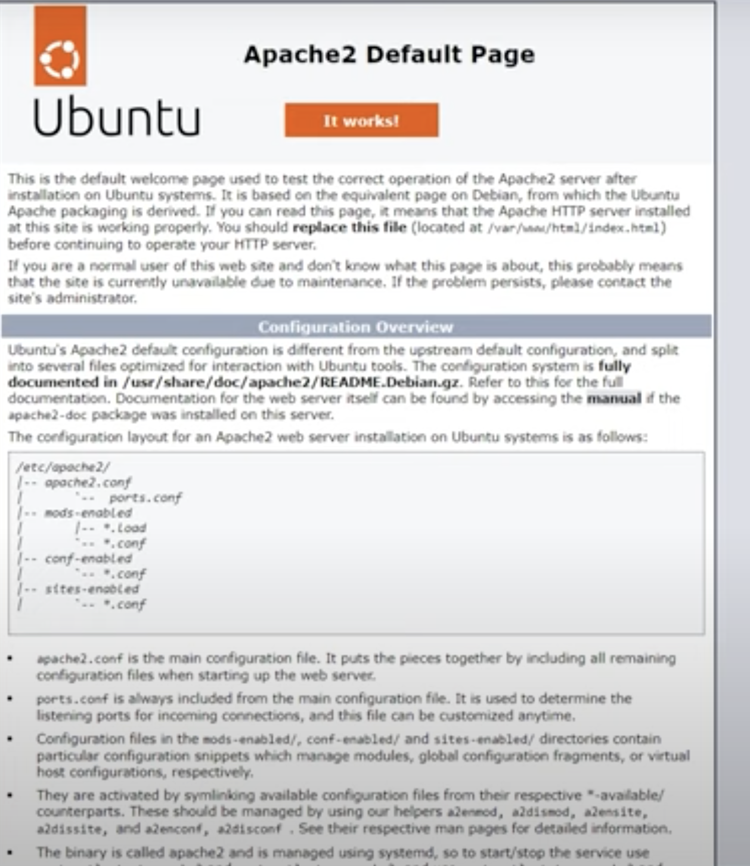

Now install php runtime on our instance and MySQL connector for php.

sudo apt install php libapache2-mod-php php-mysql

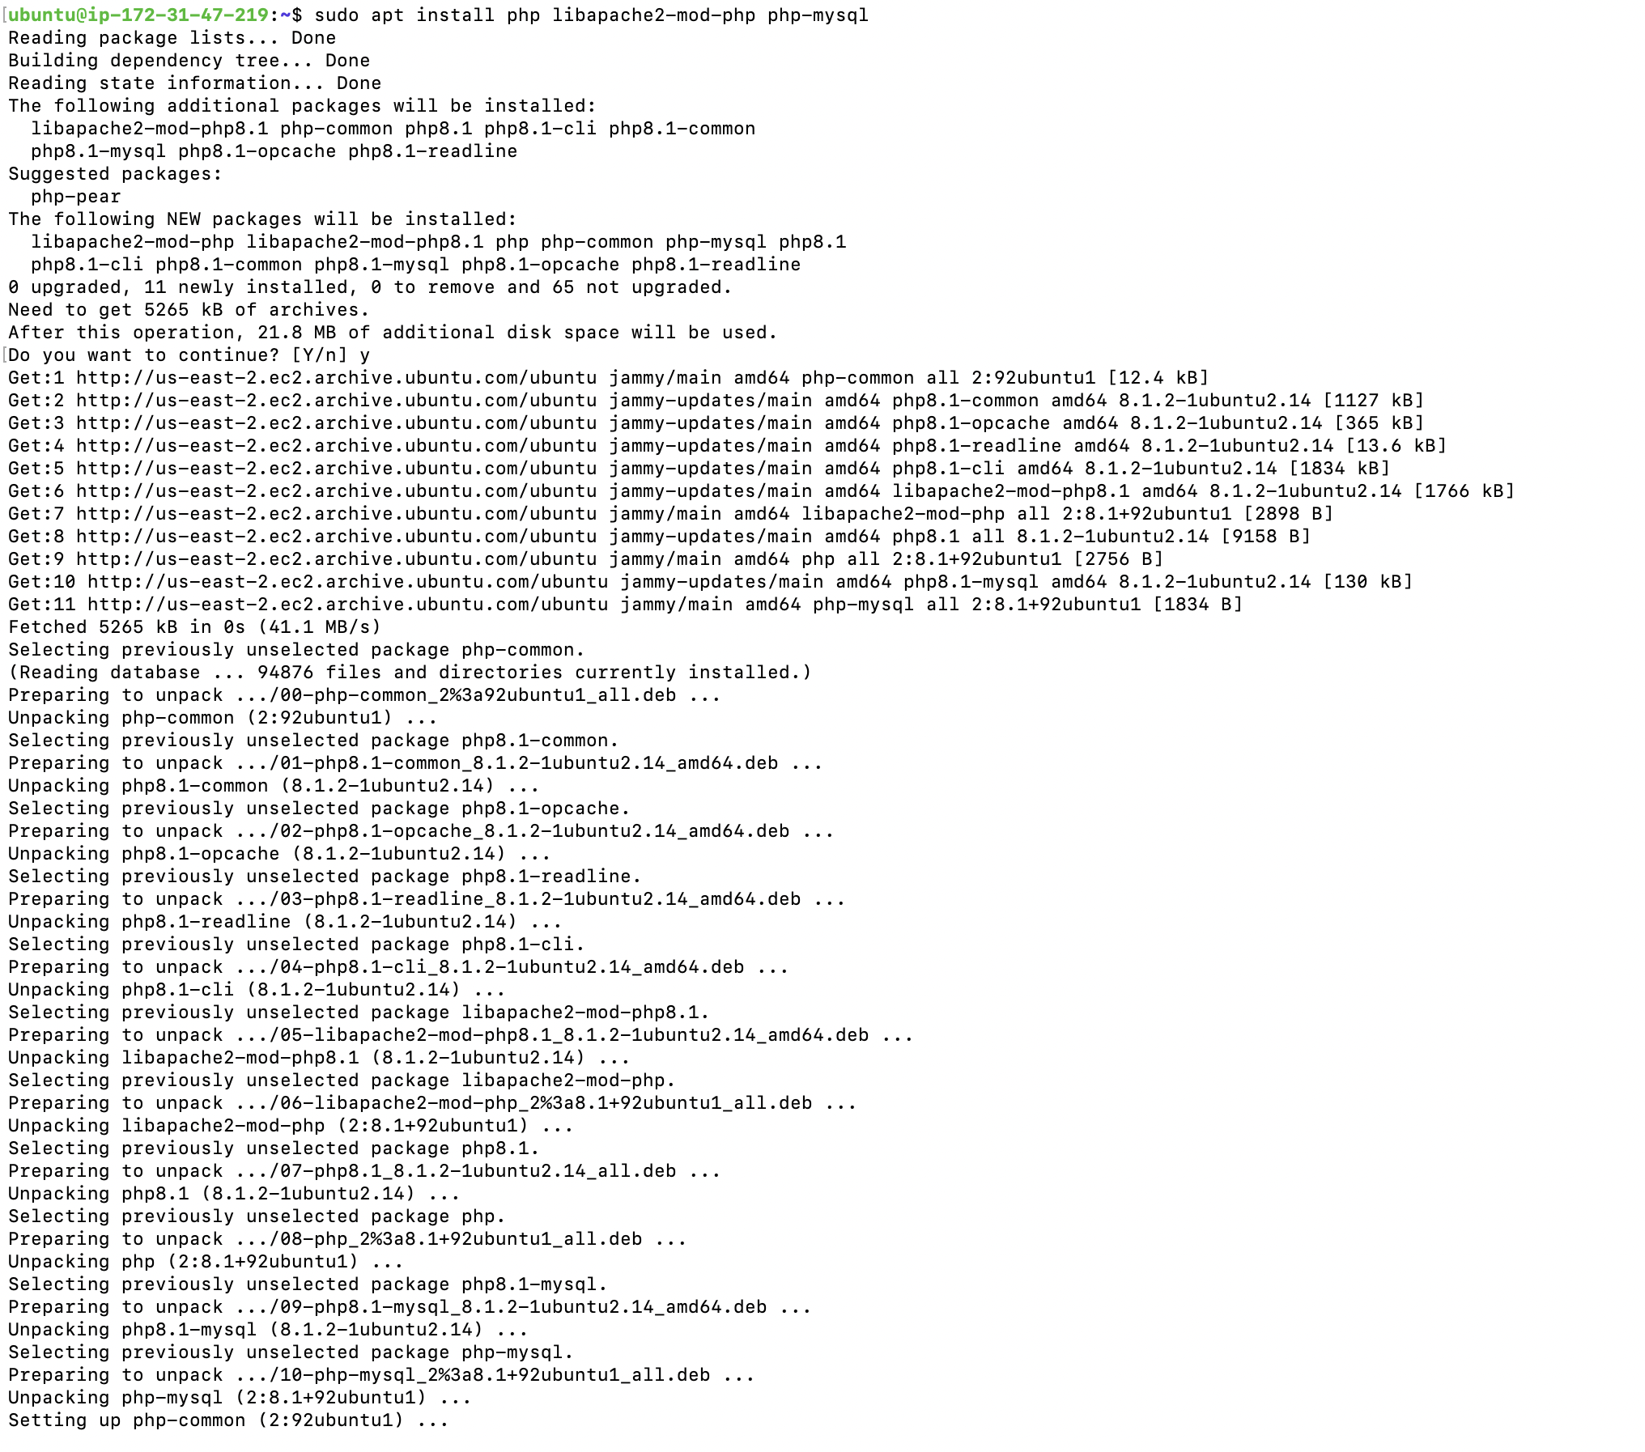

**Step3: Install MySQL database**

sudo apt install mysql-server

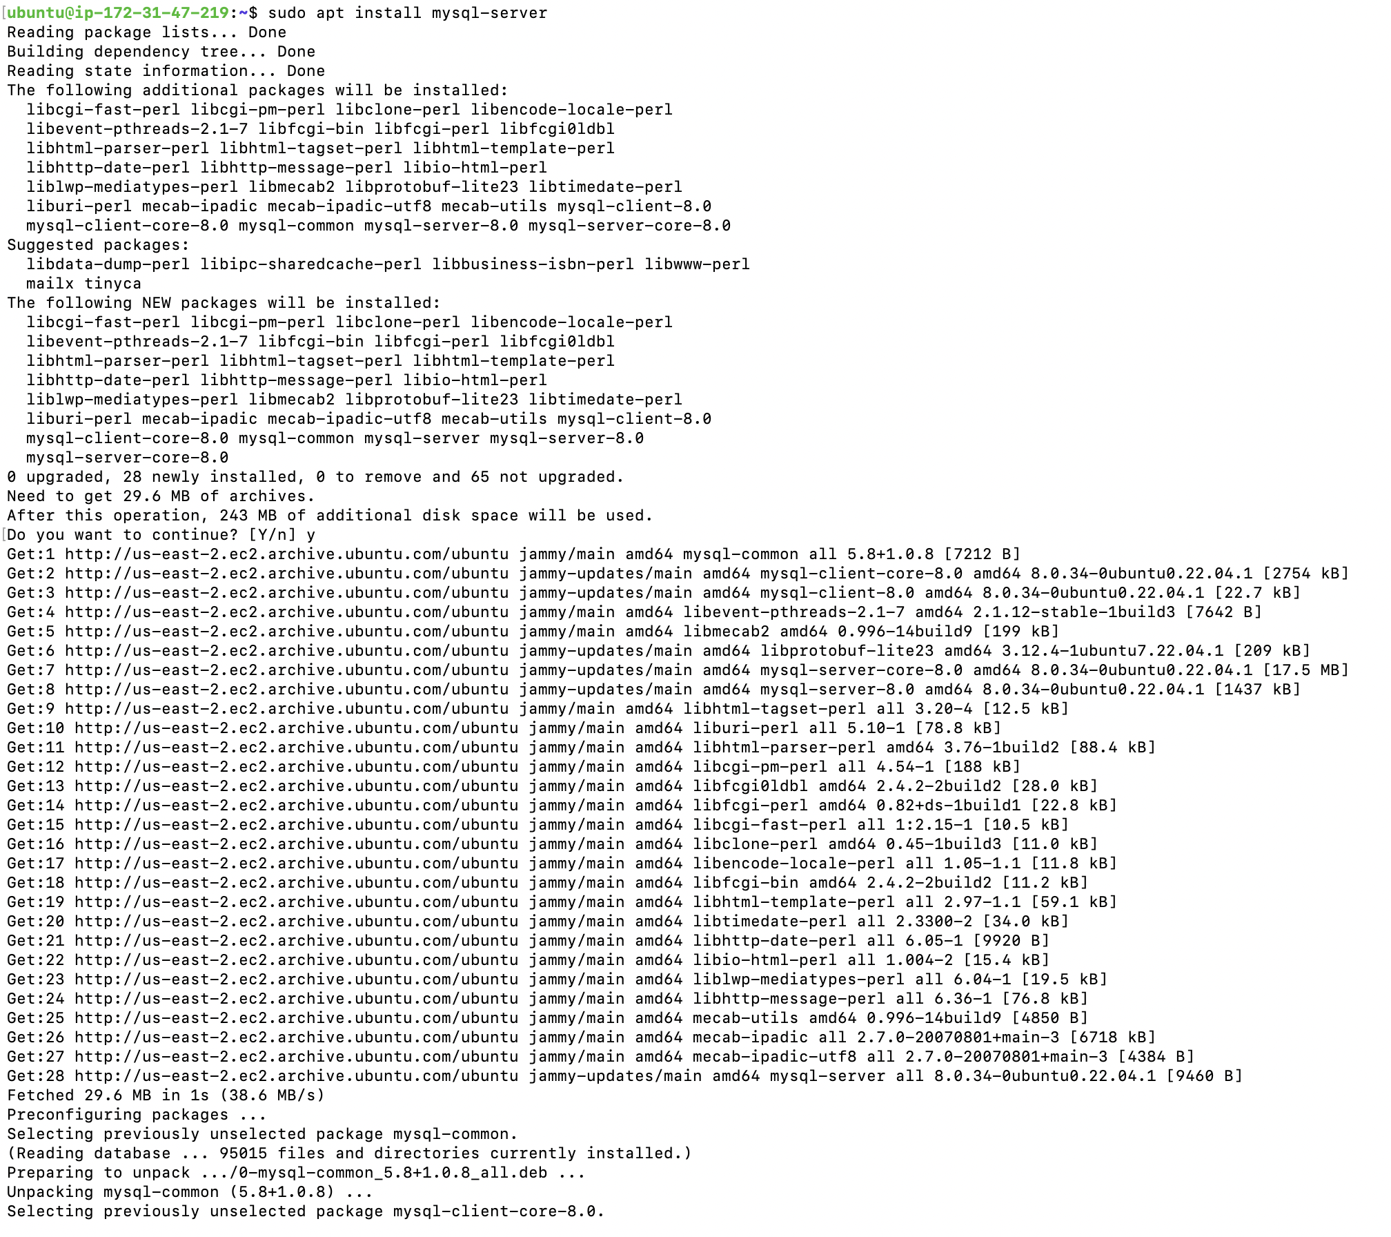

Configuration to mysql server.

Change the mysql authentication plugin to mysql_native_password. So that we can login to mysql-server with normal password.

First login to MySQL Server

sudo mysql -u root

Change the authentication plugin

ALTER USER ‘root’@’localhost’ IDENTIFIED WITH mysql_native_password by ‘TestPassword@123’;

Create a new user other than root account in order to use the wordpress.

CREATE USER ‘wp_user’@localhost IDENTIFIED BY ‘Testpassword@123’;

Create a new database for wordpress

CREATE DATABASE wp;

Grant all the privileges to the database ‘wp’ to the ‘wp_user’.

GRANT ALL PRIVILEGES ON wp.* TO ‘wp_user’@localhost;

We configured the mysql-server

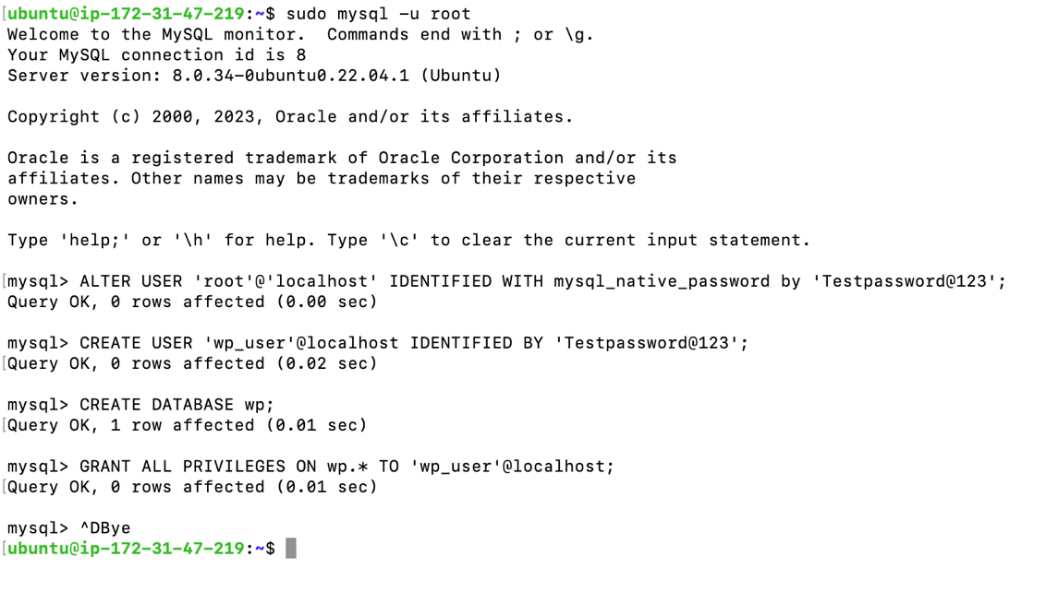

**Step 4: Download and install wordpress.**

Goto /tmp directory

Download the latest.tar.gz

cd /tmp

wget <https://wordpress.org/latest.tar.gz>

unzip

tar -xvf latest.tar.gz

Move the wordpress folder to the apache document root

sudo mv wordpress/ /var/www/html

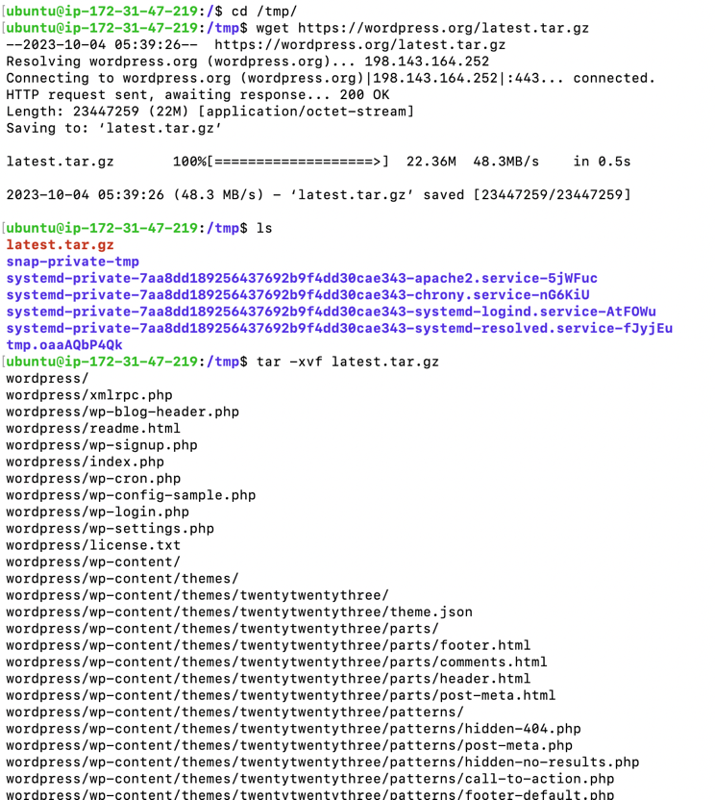

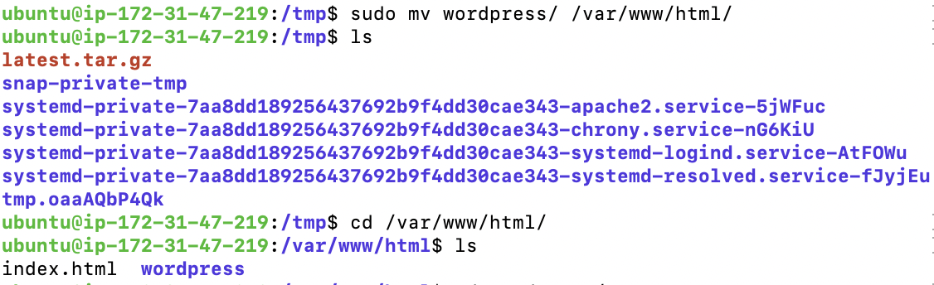

When you open the public IPV4 address in the browser(<http://3.134.156.184>/wordpress), then the wordpress installation page is displayed.

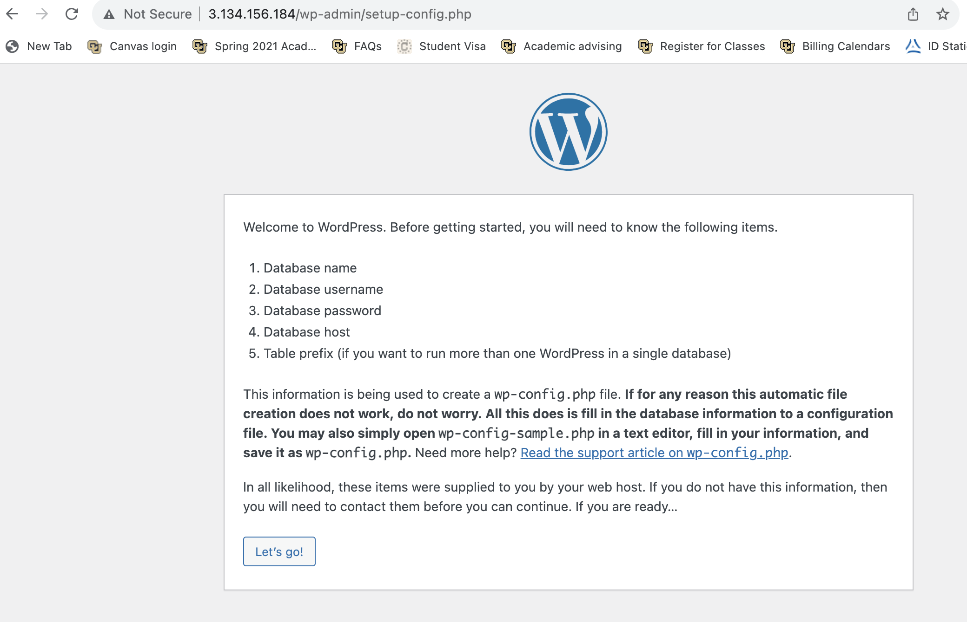

Install the wordpress, click on “Let’s go!”

Next, configure the database.

Database Name: wp

Username: wp_user

Password: Testpassword@123

Database Host: localhost

Table Prefix: wp_

Click on “submit”

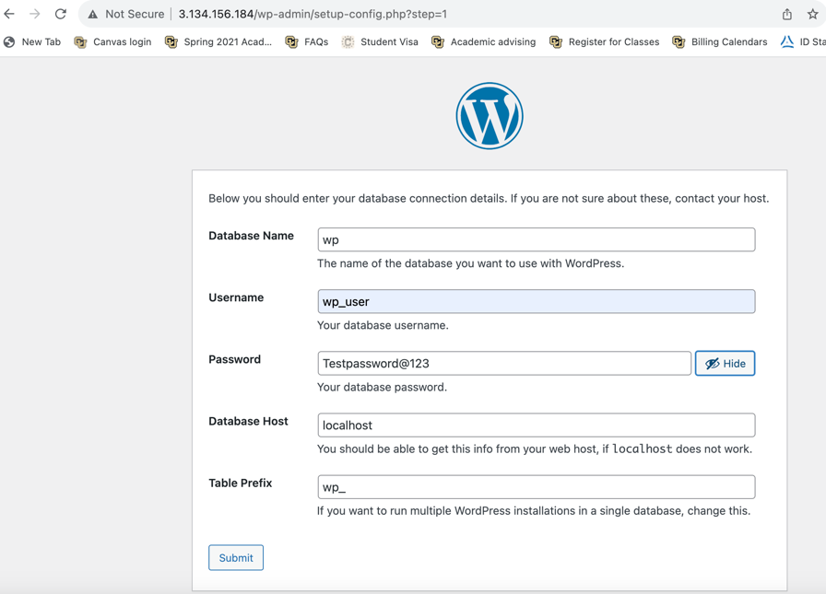

There is an error “Unable to write wp-config.php file”

So, copy the php code

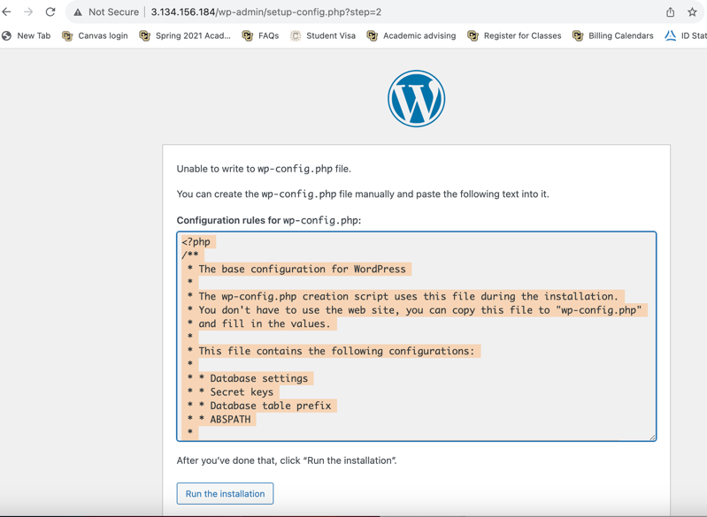

Goto terminal, Goto /var/www/html/wordpress/

cd /var/www/html/wordpress/

In the path, create a new file wp-config.php

nano wp-config.php

paste the php code.

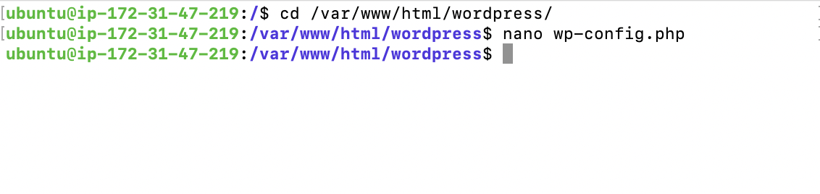

Click on “Run the installation” in the browser.

Fill the information needed

Site Title: my sample website

Username: mallikabr

Password: Testpassword@123

Your email

Click on “Install WordPress”

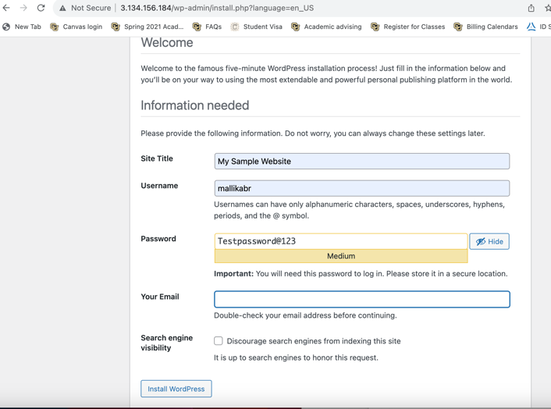

WordPress is now installed.

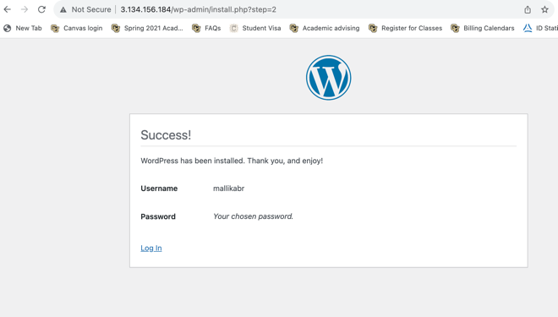

Open <http://3.134.156.184/wordpress/>

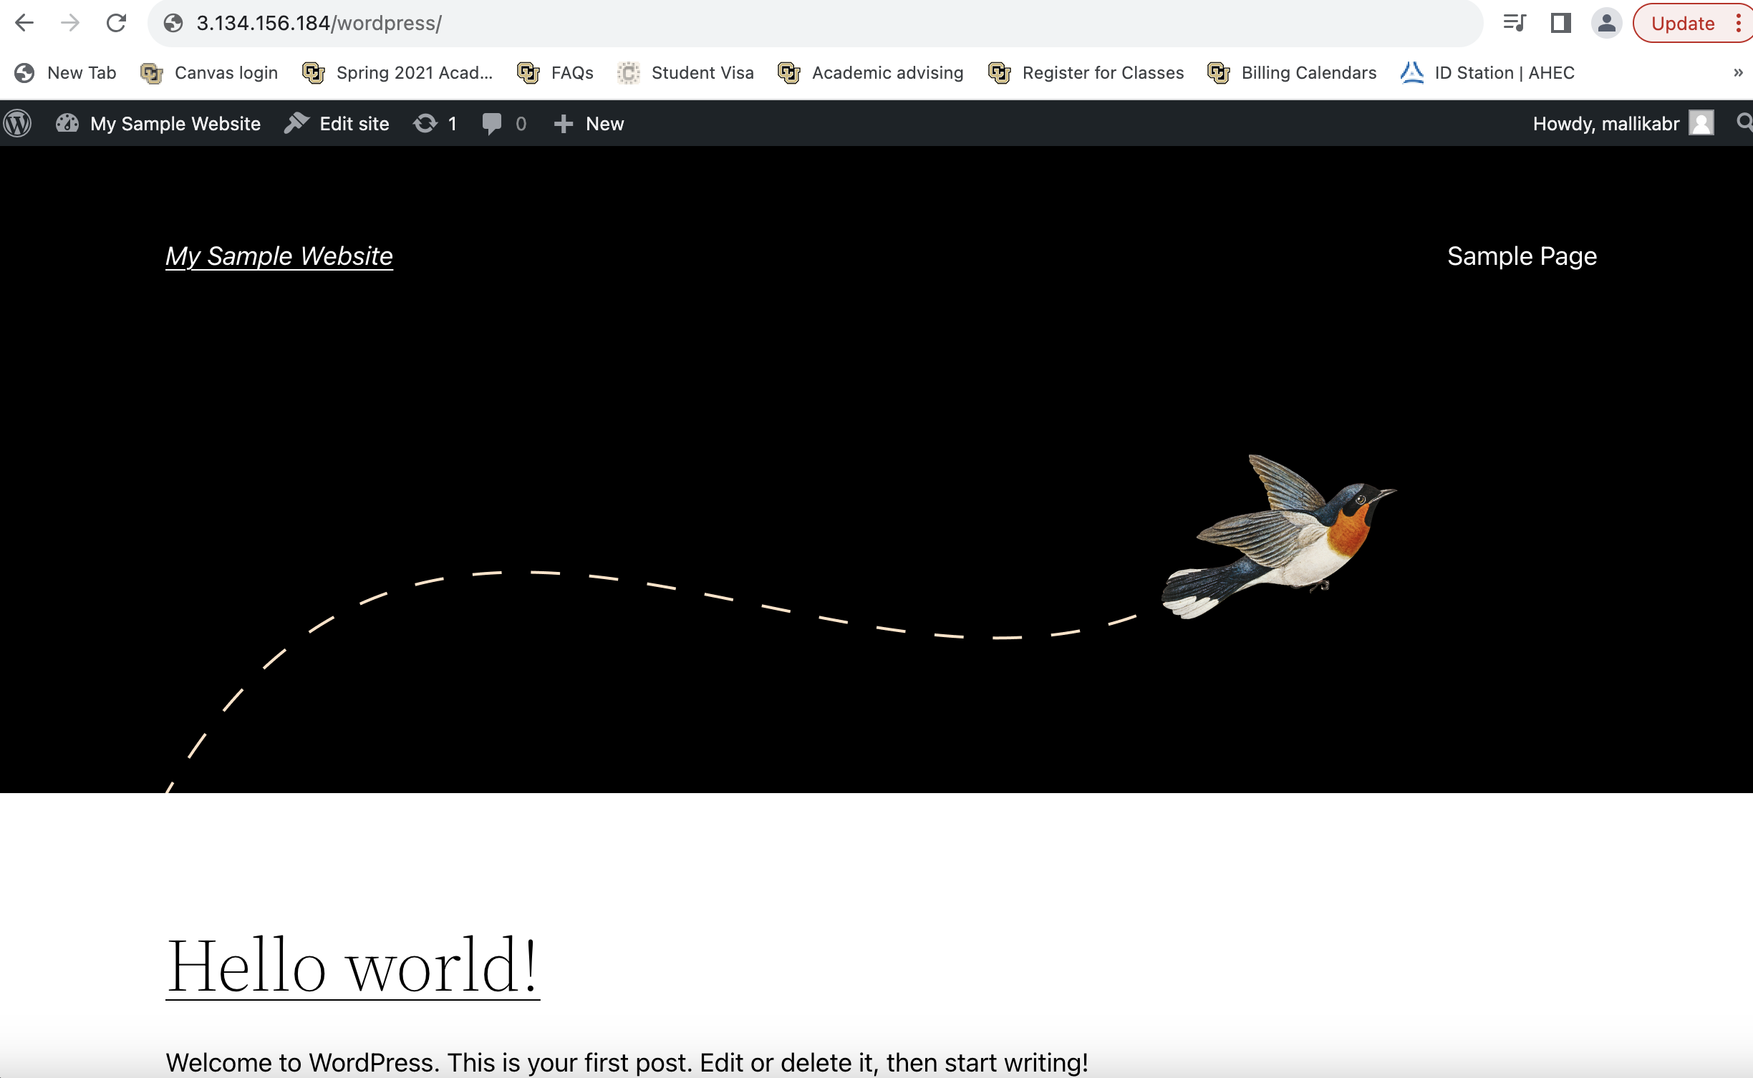

We don’t have to go to the sub path i.e., /wordpress (http://3.134.156.184/wordpress/)

The wordpress website has to be served on the root directory (<http://3.134.156.184>)

For that goto terminal, goto /etc/apache2/sites-available/

cd /etc/apache2/sites-available/

Then open the 000-default.conf (configuration file)

sudo nano 000-default.conf

change the DocumentRoot from /var/www/html to /var/www/html/wordpress

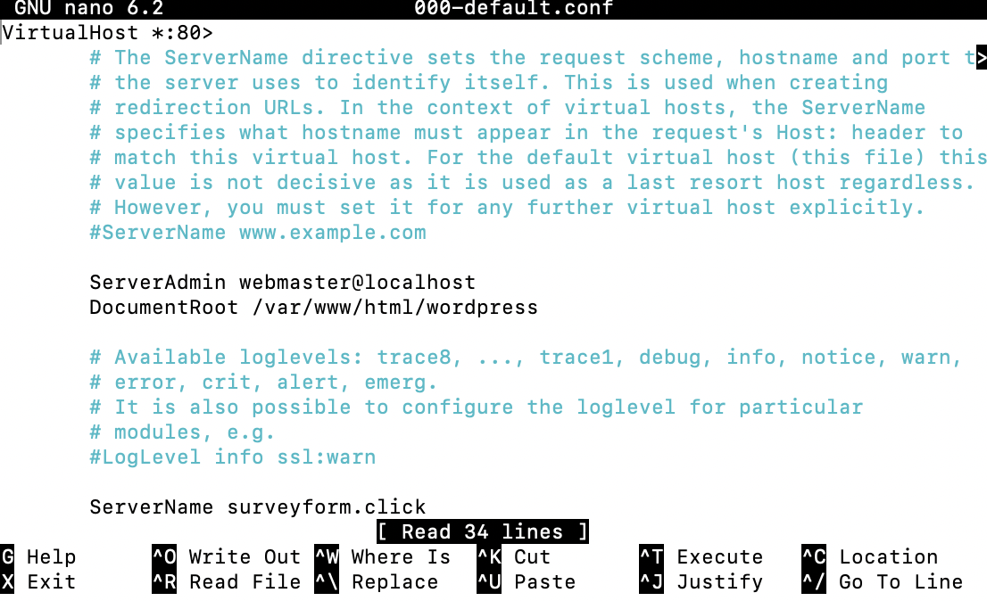

To restart the apache2

sudo systemctl restart apache2

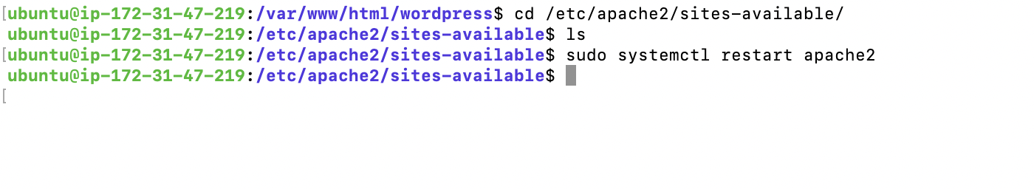

This worked!!

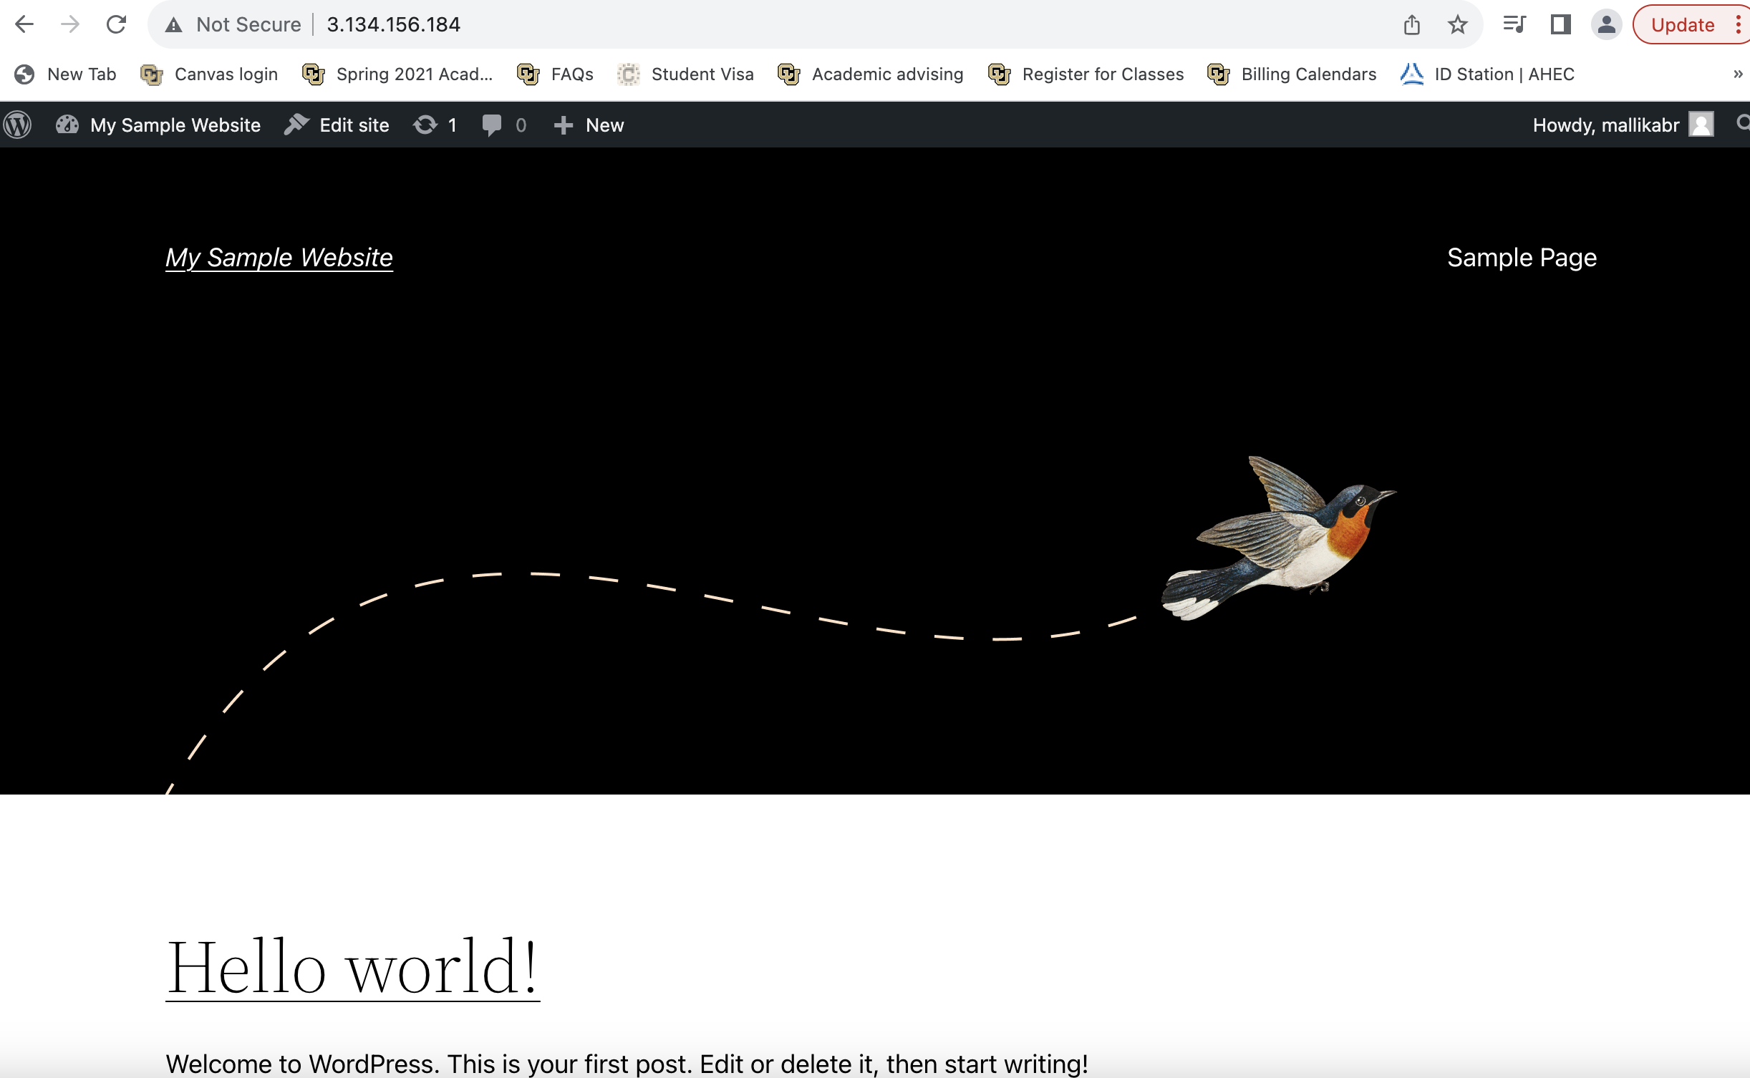

**Step5: Link a custom domain to a website**

My domain Name: mysamplewordpress.site from IONOS. Now link this domain to the wordpress.

Login to IONOS portal and click on “Domains & SSL” in home page.

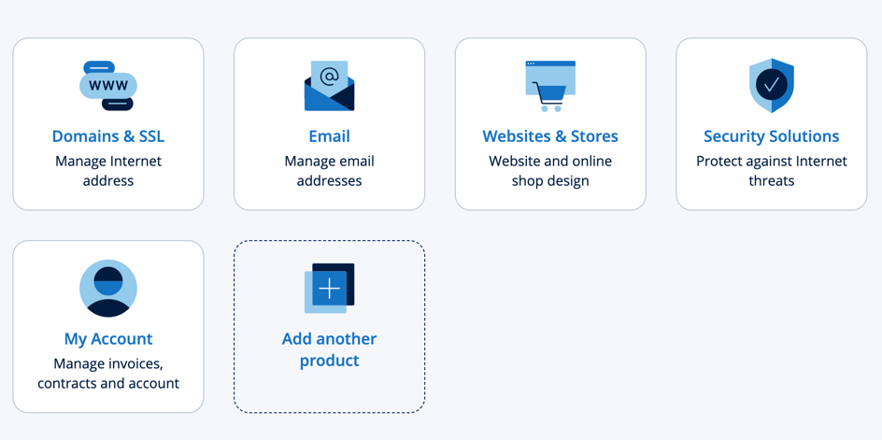

Click on “Adjust DNS Settings”, then click on “Add record”.

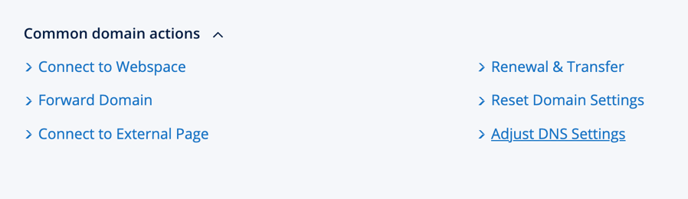

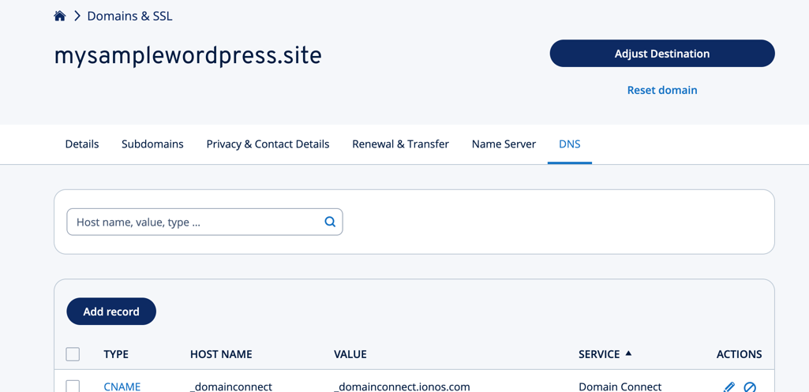

Choose A type and points to public IPV4 address i.e., 3.134.156.184 and TTL set to 60 and click on “save”.

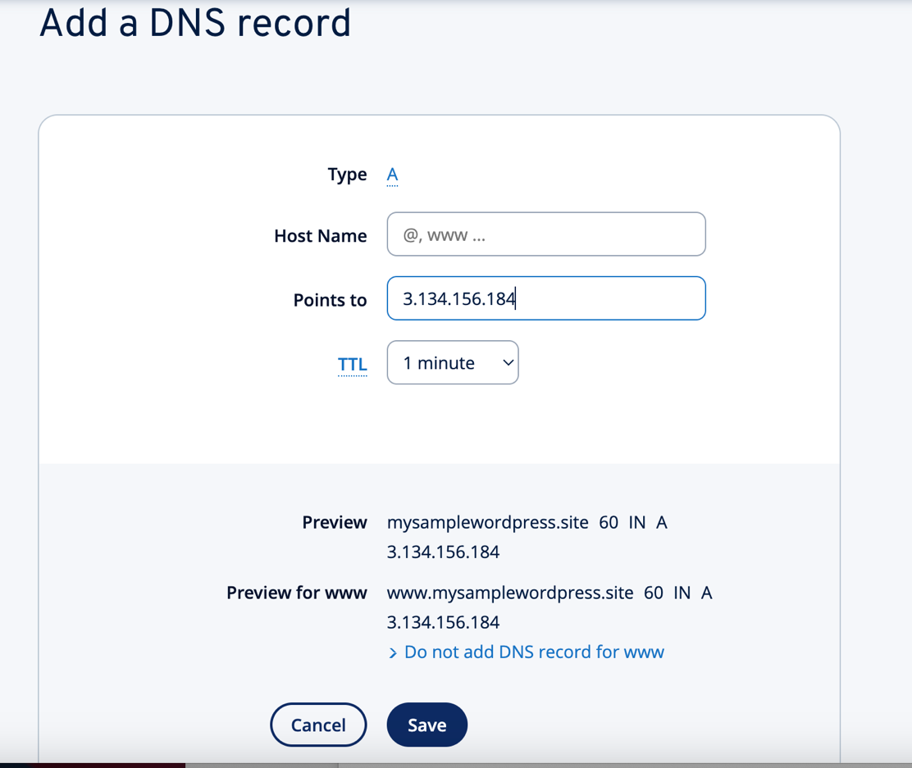

And there are some additional changes that needs to be modified in the configuration file

cd /etc/apache2/sites-available

sudo nano 000-default.conf

add the below two lines in the .conf file

ServerName mysamplewordpress.site

ServerAlias www.mysamplewordpress.site

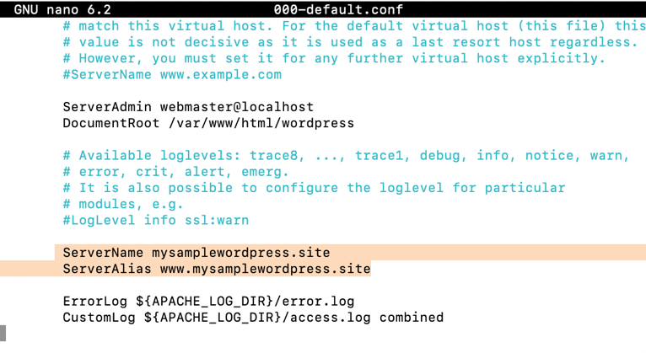

Restart the apache2

sudo systemctl restart apache2

Finally, domain name is pointing to the AWS instance. Now we can access the wordpress using the domain name.

Visit the website.

[www.mysamplewordpress.site](http://www.mysamplewordpress.site)

Now, when you visit [www.mysamplewordpress.site/wp-admin](http://www.mysamplewordpress.site/wp-admin), it is redirecting the public IPV4 address. To fix this,

Login to the wordpress, In the Dashboard, Goto Settings, then click on General. Modify the Wordpress Address (URL): <http://mysamplewordpress.site>

Site Address(URL): <http://mysamplewordpress.site>

Click on “Save changes”

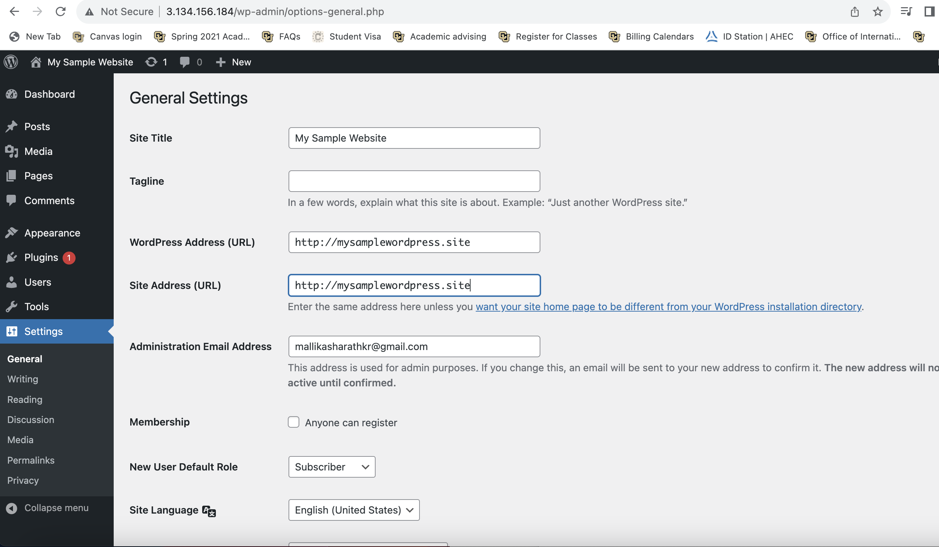

Now, the website points to domain name.

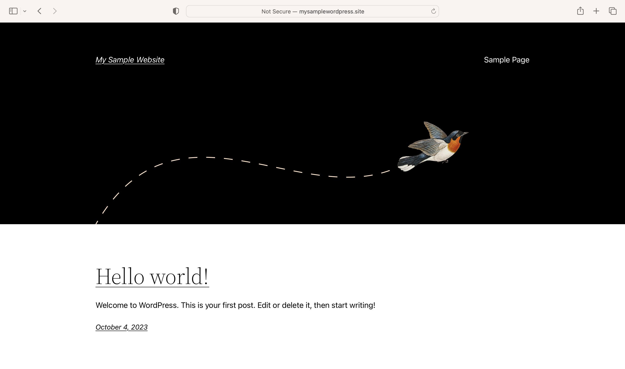

Here the website is not secure. It has to work over https.

We need to install certbot.

sudo apt install certbot python3-certbot-apache

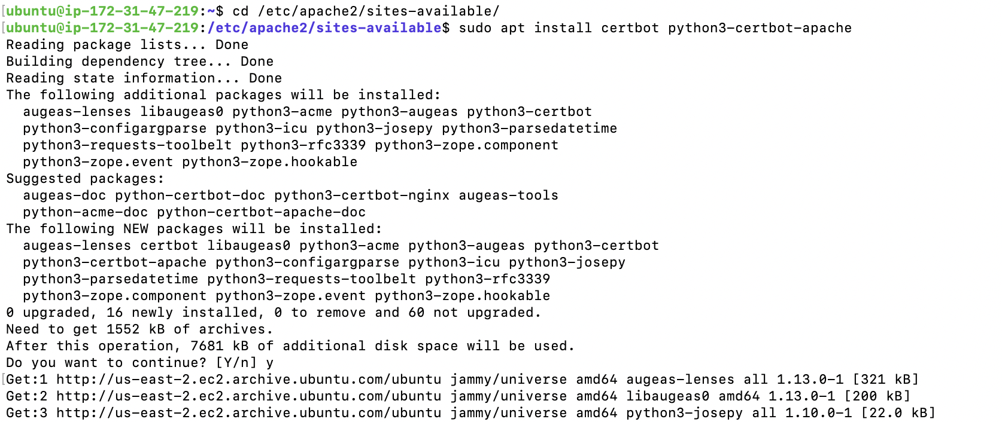

Run the command to secure the apache with SSL certificate

sudo certbot –apache

prompts for an email address and enter

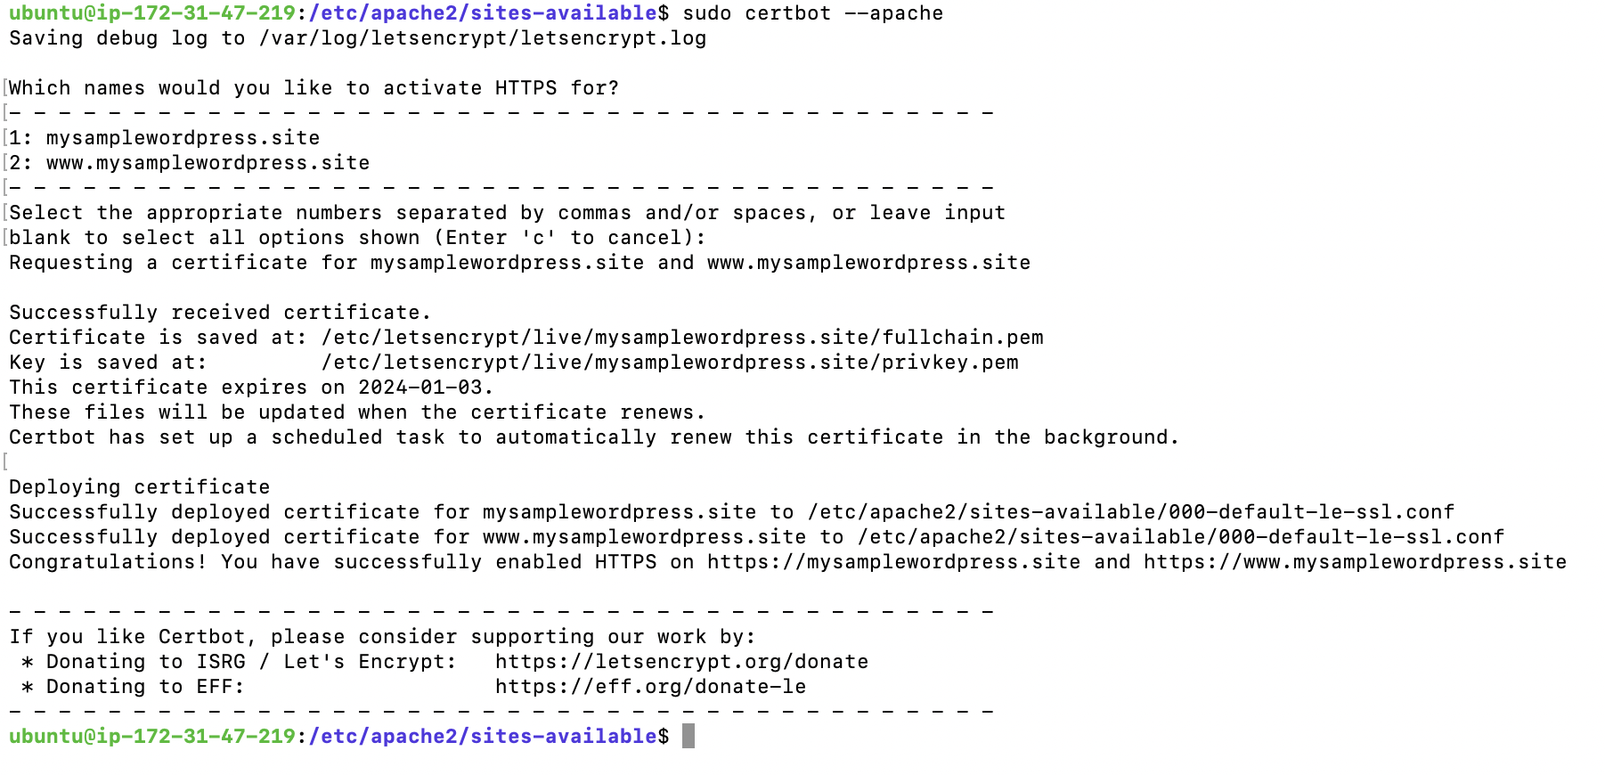

Successfully deployed certificate for both mysamplewordpress.site and www.mysamplewordpress.site

The certificate issued by R3, Let’s Encrypt

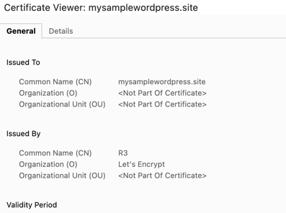

Now the domain is secure and works over https. So, you can view wordpress website on the custom domain.

